**Download keystore certificate create tools below is url**

Url link=https://keystore-explorer.org/downloads.html

Software name=kse-552-setup

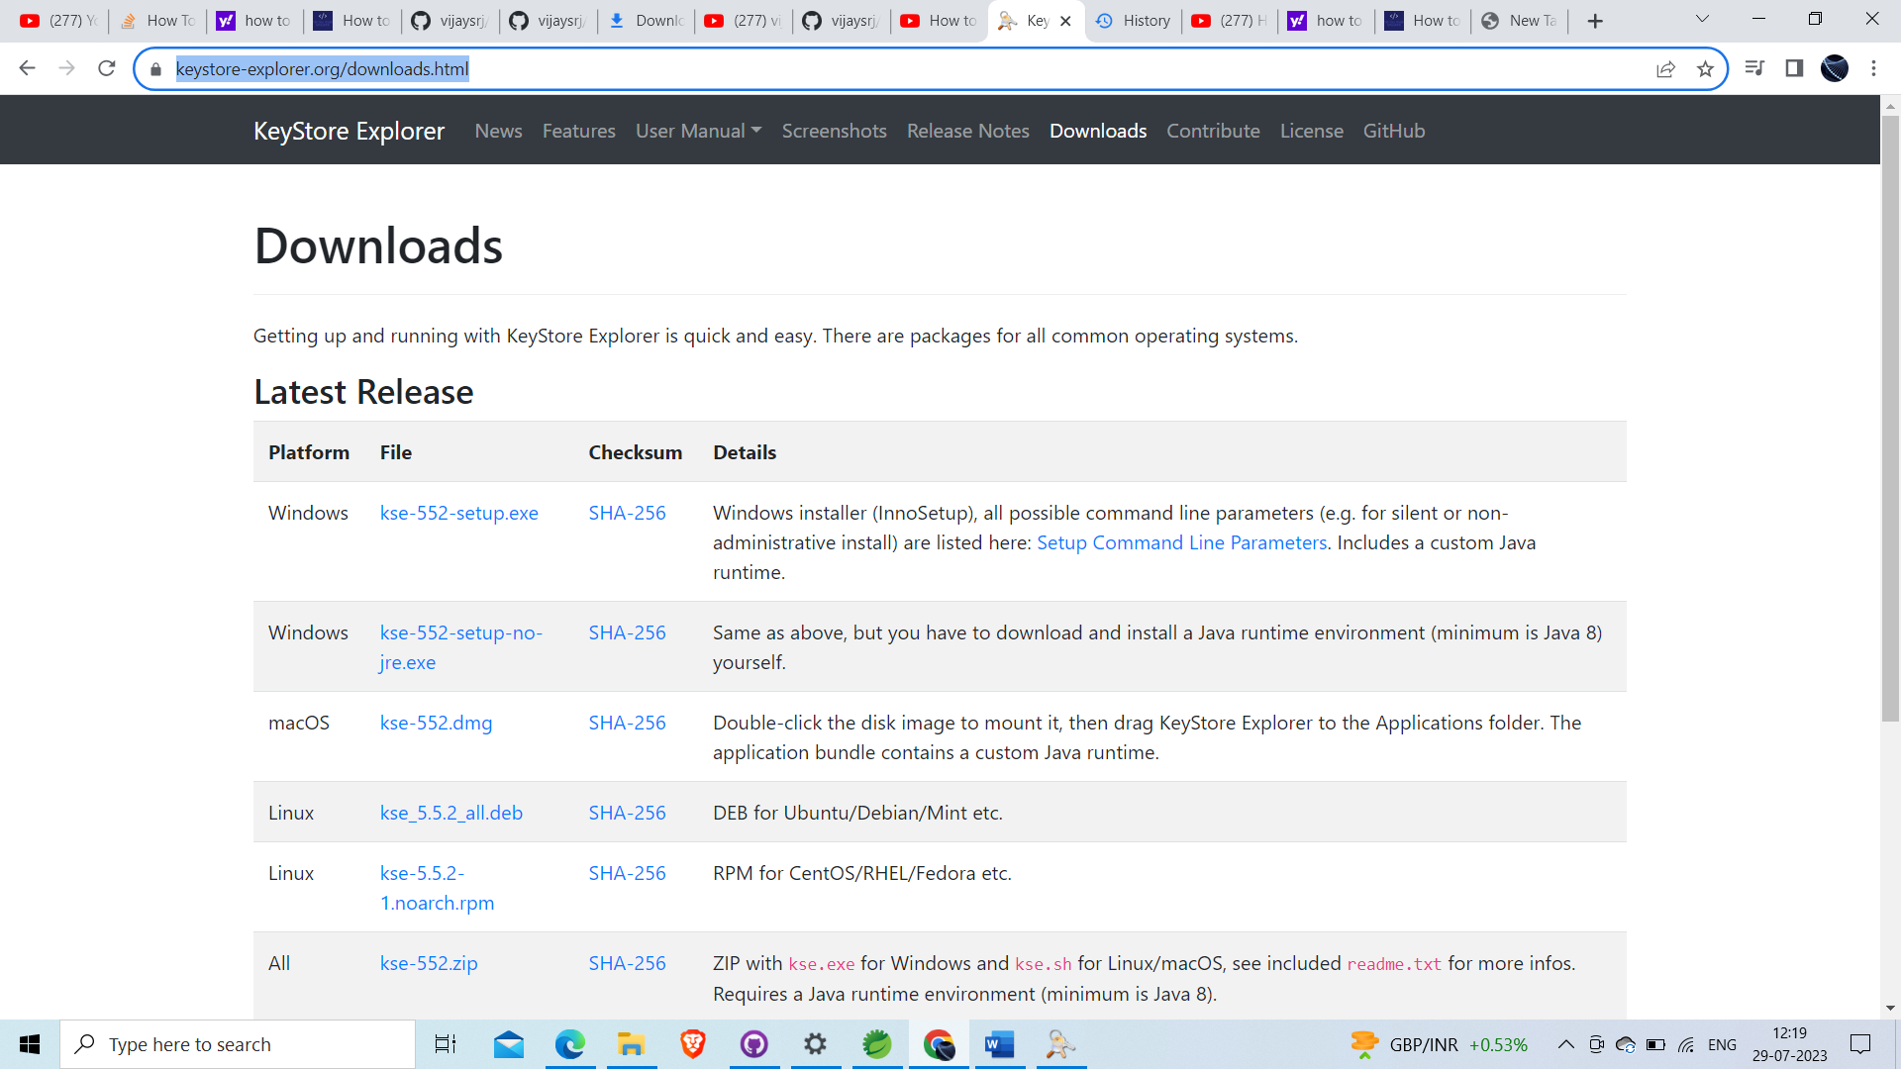

Steps – download exe file as your environment like window/linux/MacOS

--- Install on your machine

--- open then goto the file and open new

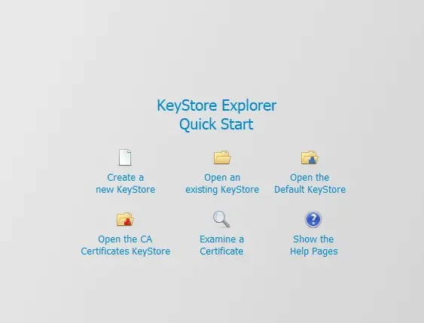

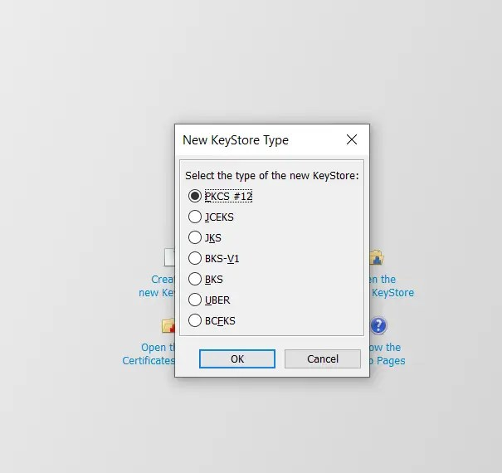

Click on Generate Key Pair:

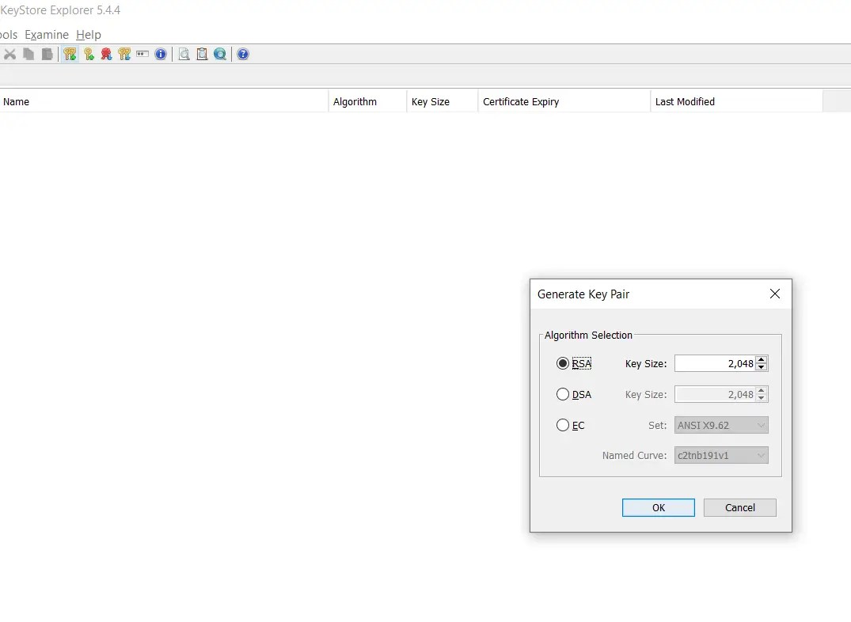

Click on the icon near Name

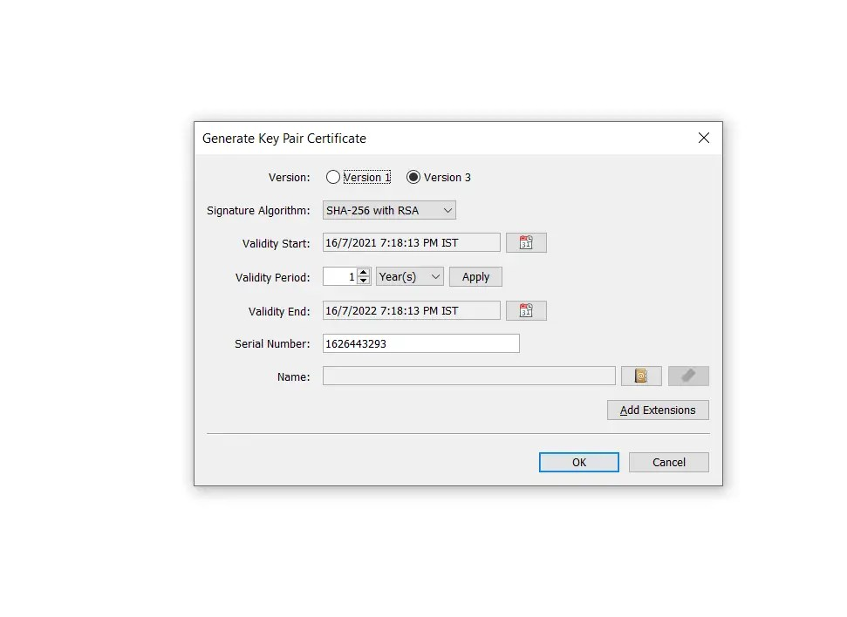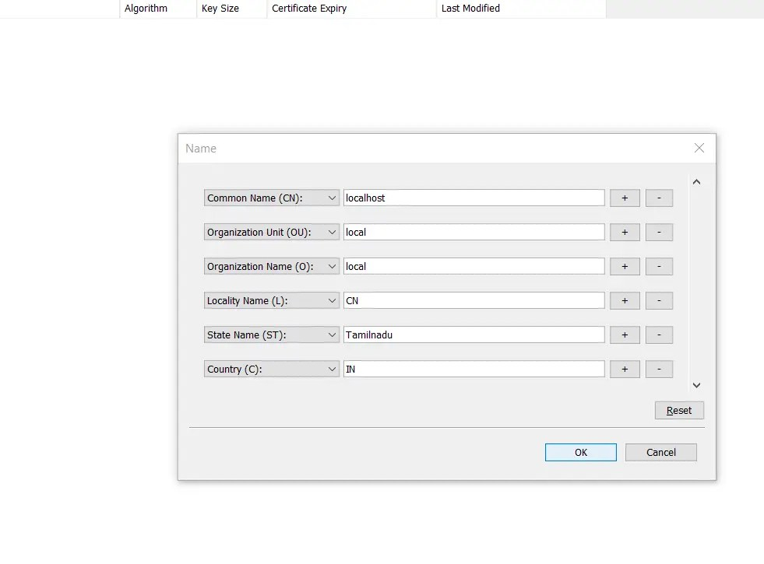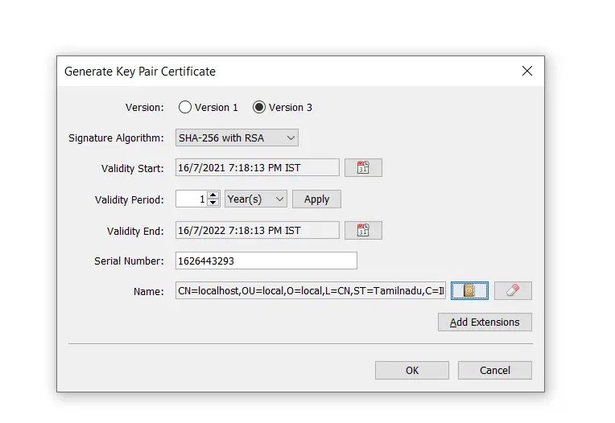

Click on Add Extensions. You need to do this to add your domain and ip address in case if you are testing from your local machine

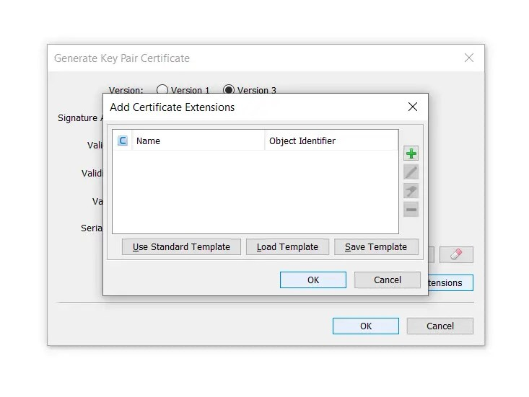

Choose extension type as Subject Alternative Name:

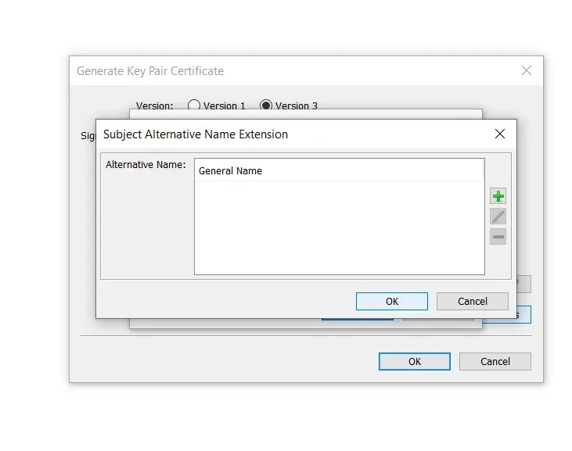

Under that add DNS and IP address:

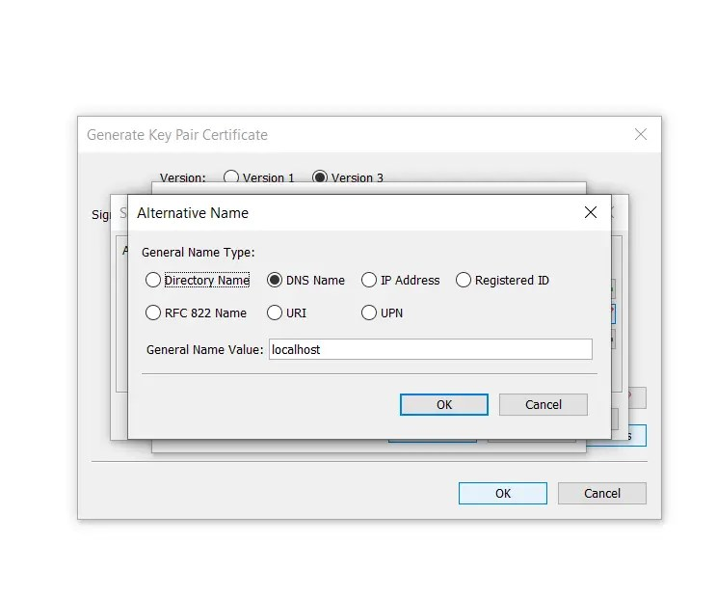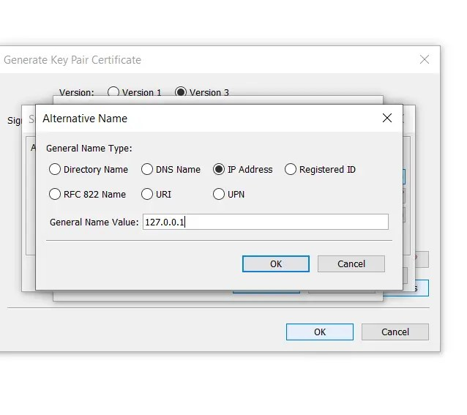

Give an alias name and password:

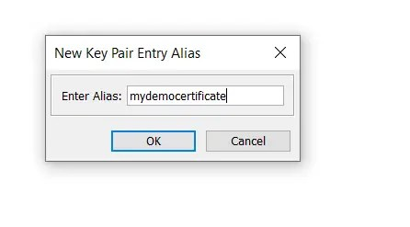

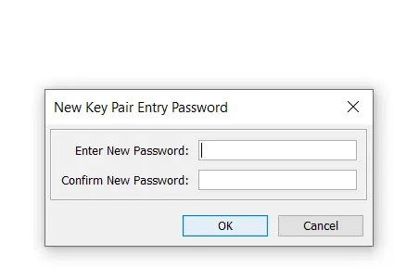

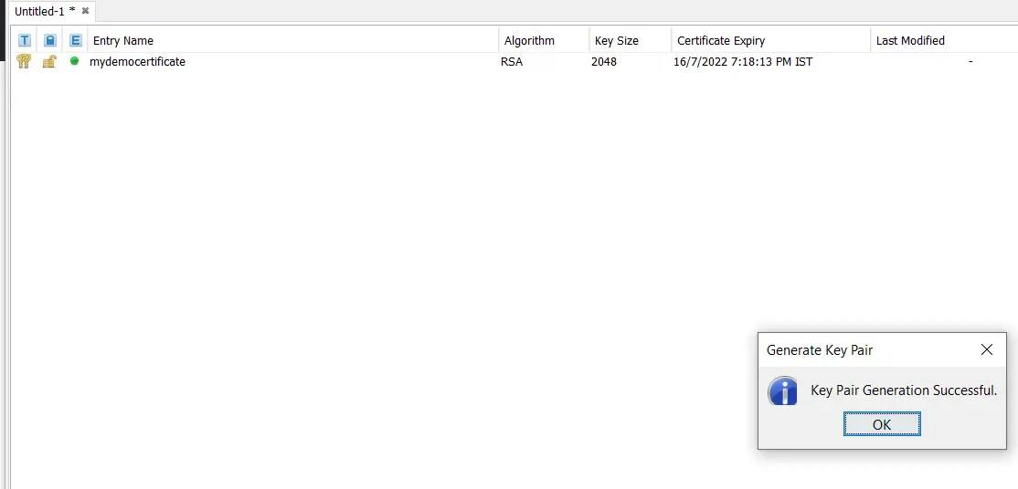

Save the keystore with .p12 extension after giving a password for the keystore just like you gave for keypair:

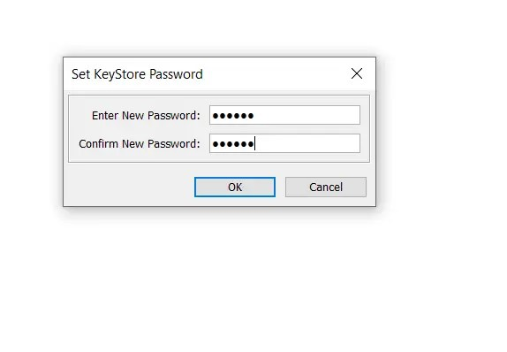

The keystore is now ready with the certificate I created!

As already mentioned you can import any certificate directly into the keystore instead of creating a new key pair.

Before consuming a secured REST API , let’s see how to create a secured REST API first using the above keystore.

To do this , just place the keystore you created using the above steps in the resources folder of the application you want to protect:



Click on Generate Key Pair:



Click on the icon near Name



Click on Add Extensions. You need to do this to add your domain and ip address in case if you are testing from your local machine



Choose extension type as Subject Alternative Name:



Under that add DNS and IP address:



Give an alias name and password:







Save the keystore with .p12 extension after giving a password for the keystore just like you gave for keypair:



The keystore is now ready with the certificate I created!

As already mentioned you can import any certificate directly into the keystore instead of creating a new key pair.

Before consuming a secured REST API , let’s see how to create a secured REST API first using the above keystore.

To do this , just place the keystore you created using the above steps in the resources folder of the application you want to protect: